# **13 Reasons Why Healthcare Companies Should Use a BPO**

The healthcare industry is at the forefront of our society, continually adapting to technological advancements, policy changes, and growing population demands. Given this landscape, healthcare providers need efficient and cost-effective solutions to maintain their operations smoothly. Business Process Outsourcing (BPO) has emerged as a reliable solution for such challenges. BPOs can offer multiple benefits that improve the operational efficiency of healthcare companies.

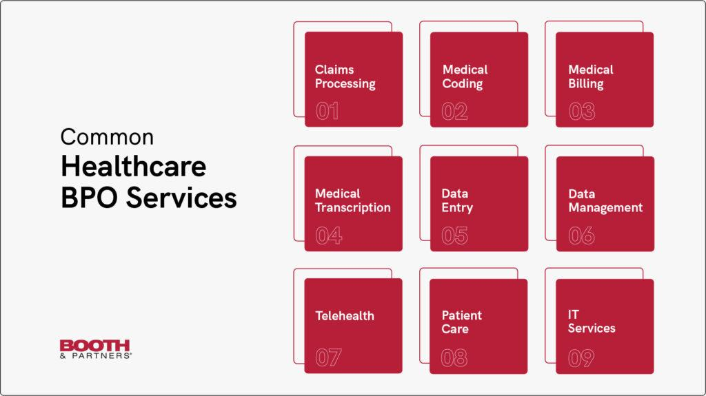

[Source](https://boothandpartners.com/wp-content/uploads/2022/04/Blog-Infographics_HealthcareServices-1024x575.jpg)

Here are thirteen reasons why healthcare companies should consider utilizing a BPO:

## **1. Cost Savings**

Undoubtedly, the most persuasive argument for outsourcing to Business Process Outsourcing (BPO) companies lies in the realm of cost-efficiency and the effective utilization of resources. When healthcare organizations contemplate outsourcing their non-core activities to BPOs, it's not merely an off-the-cuff decision but a strategic move with significant financial implications.

Such a decision can usher in substantial cost savings for these healthcare institutions, which frequently grapple with the financial challenges related to staffing. This includes the salaries and the essential resources that go into the recruitment, onboarding, and ongoing training of in-house teams. Moreover, the additional costs associated with benefits, leave allowances, and infrastructural requirements also add up. In contrast, these expenses can be dramatically reduced when these tasks are delegated to a BPO.

Healthcare BPO services have built their business model around providing these same services, specializing in them to the degree that allows them to operate at a lower cost without compromising the quality of service. This results from their ability to achieve economies of scale - a cost advantage gained when an entity's output increases, leading to lower average cost per unit as fixed costs are spread out over more units.

As BPOs cater to multiple clients simultaneously, they can spread their operational costs across these various contracts, driving down the average cost. This cost advantage is passed on to their clients, enabling the BPOs to provide these services at a fraction of the cost that healthcare companies would incur if they performed the tasks in-house.

## **2. Access to Specialized Skills**

BPO firms are widely recognized for their exceptional services extending over many sectors. These include, but are not limited to, medical billing, coding, transcription, patient services, etc. This diversification of skills and services results from years of hands-on experience and continuous professional development, solidifying BPOs' reputation as a reliable and convenient solution for healthcare providers who require these specialized services.

When healthcare providers outsource these tasks to BPOs, they tap into a reservoir of knowledge and expertise. This vast pool comprises professionals who have dedicated their careers to becoming specialists in their respective fields. Their mastery over their areas of specialization ensures that they carry out their tasks accurately, efficiently, and quickly, which is hard to match.

BPOs employ many experts, each bringing their unique skill sets and depth of knowledge to the table. From medical coders and billers, who ensure that each procedure, diagnosis, and treatment is accurately recorded and billed, to transcriptionists, which convert voice-recorded medical reports into written documents, these professionals perform their duties with great attention to detail and accuracy. Moreover, compassionate and skilled staff in patient services handle patient inquiries, appointments, and support, enhancing the overall patient experience.

## **3. Enhanced Data Security**

Data security holds a prominent position in the healthcare sector due to the compassionate nature of medical records. These documents contain personally identifiable information and critical medical data entry that, if mishandled, can lead to serious privacy breaches and potential legal consequences. Therefore, it's essential that these records are meticulously managed and fiercely protected.

Business Process Outsourcing (BPO) companies understand the importance of this responsibility and have accordingly put in place robust security measures to safeguard the integrity of such sensitive data. This commitment to data security is not merely a business practice but forms the cornerstone of its operational model.

BPOs typically employ a comprehensive range of security measures, including advanced encryption techniques, secure servers, and stringent access controls, among other things. These protocols are designed to minimize the risk of unauthorized access, data breaches, and data loss, ensuring that patient information remains confidential and secure at all times.

## **4. Scalability**

The nature of healthcare services is such that demand can oscillate dramatically, influenced by various factors like seasonal illnesses, public health crises, or changes in population demographics. In-house management of these fluxes can pose a considerable challenge for healthcare organizations as they try to balance meeting increased demand during busy periods and minimizing resource wastage during slower times.

This is where BPO companies come into play with their ability to offer scalable solutions. The essence of these solutions lies in their adaptability - BPOs can adjust the volume of their services in response to the changing needs of the healthcare company. This dynamic approach allows them to ramp up their services during periods of high demand and scale back when the workload decreases. This scalability ensures that the healthcare provider can consistently meet their patients' needs, irrespective of fluctuations in the market.

The ability to scale services is integral to a BPO's offering, providing crucial flexibility in the healthcare sector. This flexibility allows healthcare providers to navigate peak periods efficiently, ensuring that administrative tasks do not become bottlenecks that impede the delivery of healthcare services.

## **5. Focus on Core Business Activities**

Outsourcing is a strategic approach that permits healthcare providers to channel their focus toward their fundamental objective: delivering high-quality, patient-centered care. This core mission forms the backbone of any healthcare organization and directs all its actions. However, administrative tasks and other ancillary functions often consume substantial time and resources, detracting from this primary goal.

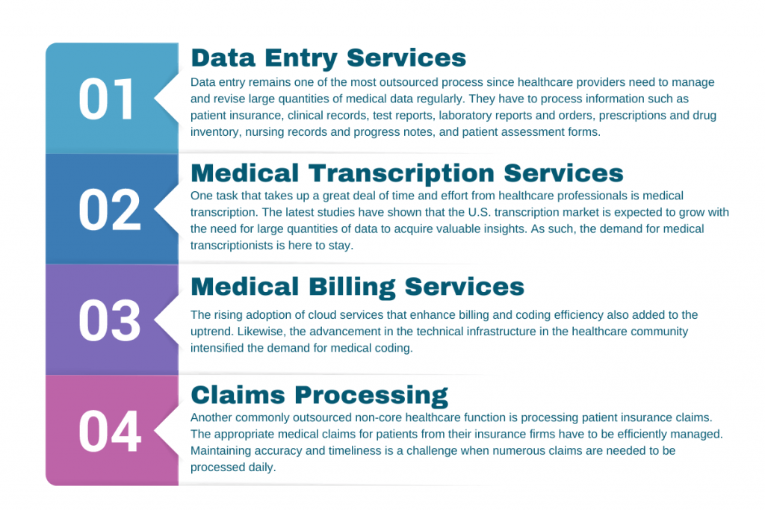

[Source](https://unity-connect.com/wp-content/uploads/2022/04/Four-Commonly-Outsourced-Healthcare-Services-1024x683.png)

BPO companies come into the picture as effective partners in managing these essential yet non-core functions. BPOs are well-equipped to handle many tasks, including administrative duties, medical billing, coding, and many other functions that, while critical to operations, do not directly contribute to patient care.

When healthcare providers delegate these tasks to BPOs, they effectively free themselves from the operational burden these functions impose. No longer burdened by these duties, healthcare professionals can devote their time, energy, and resources to activities that directly impact patient care. They can focus more on diagnosis and treatment, patient counseling, research, continuing education, and other critical aspects of healthcare delivery.

The time gained through outsourcing can be invested in enhancing the patient experience, from improving the quality of care to ensuring patient comfort and satisfaction. Resources that would have been allocated to manage administrative tasks can now be redirected towards acquiring advanced medical equipment, funding research, providing staff training, and other areas that can directly or indirectly improve patient care.

## **6. Improved Patient Satisfaction**

Healthcare organizations can significantly enhance their operational efficiency by strategically choosing to outsource their administrative functions. Through the decision to outsource, these organizations can redirect their internal resources towards core healthcare services, thus bringing about a noticeable improvement in the overall patient experience.

One of the primary areas impacted by outsourcing is the billing process. In the healthcare industry, billing is a critical yet complex process involving multiple steps, from coding medical procedures correctly to submitting claims to insurance companies. Mistakes during these stages can lead to billing errors, causing patient distress and dissatisfaction. However, by outsourcing this function to BPO companies specializing in medical billing, healthcare organizations can ensure high accuracy and efficiency in their billing process.

BPO companies employ professionals well-versed in medical coding and billing, reducing the likelihood of errors. As a result, patients are less likely to face issues related to billing discrepancies. This accuracy facilitates a smooth billing process and fosters a sense of trust and satisfaction among patients, who can be assured of a transparent and error-free billing process.

## **7. Use of Advanced Technology**

In the healthcare sector, technology is not just an advantage; it's an essential element that drives operations, enhances efficiency, and ensures precision. BPOs understand technology's pivotal role in this industry and have adapted their processes accordingly. They employ the latest software solutions, automation tools, and cutting-edge technologies that enable them to deliver high-quality, efficient services.

When healthcare organizations choose to collaborate with BPOs, they gain the opportunity to benefit from this advanced technology. Notably, they can do so without substantially investing in acquiring and maintaining such high-tech infrastructure. Instead, they can leverage the technological capabilities of the BPOs, which continuously invest in and update their specialized tools to stay abreast of the latest developments and best practices in the industry.

This indirect access to state-of-the-art technology can significantly enhance the operational efficiency of healthcare organizations. Advanced software solutions and automation tools expedite processes, reduce the chance of human error, and provide greater consistency in tasks, thus improving overall productivity.

## **8. 24/7 Support**

BPO companies often provide round-the-clock services, ensuring constant support. This feature is precious in healthcare, where service requirements can arise anytime. 24/7 support ensures that administrative tasks, customer queries, and other non-core functions are handled promptly, regardless of the time of day.

## **9. Process Optimization**

With their specialization in administrative tasks, BPOs have the expertise to optimize these processes for maximum efficiency. This expertise can lead to faster turnaround times, more accurate results, and better operational flow.

## **10. Disaster Recovery**

Healthcare BPO companies play a critical role in many industries, including healthcare. One key aspect they bring to the table is their robust disaster recovery plans. These plans are meticulously designed and implemented to ensure business continuity during unforeseen catastrophes or disruptive events. Such powerful strategies are crucial in an industry like healthcare, where disruption of services can have significant repercussions.

These disaster recovery plans often encompass many elements, including medical data backups, patient data, redundant systems, and health insurance portability. Data is the lifeblood of any organization, especially in the healthcare sector, where patient records, treatment histories, billing details, and other sensitive information are integral to daily operations. To ensure the safety and availability of this data, BPOs maintain regular data backups. These backups serve as a safety net, providing that vital information can be restored swiftly and seamlessly during data loss.

## **11. Reducing Risk**

Outsourcing medical services to a BPO can help manage and mitigate risk. Regulatory compliance in the healthcare industry is complex and constantly evolving. BPOs are adept at keeping up with these changes and ensuring that processes are compliant, reducing the risk of costly fines or litigation for healthcare providers.

## **12. Enhanced Competitive Advantage**

Leveraging the services of a Business Process Outsourcing (BPO) firm empowers healthcare companies not just to match strides with their competitors, but potentially even outpace them in terms of operational efficiency and patient service quality. The dynamic healthcare landscape is fiercely competitive, and standing out in this field necessitates the optimal utilization of resources, advanced technology, and skilled professionals. By associating with a BPO, healthcare organizations can effectively tap into these elements, thereby enhancing their competitive positioning.

BPOs bring advanced technological solutions, from state-of-the-art software to automation tools, which healthcare companies can employ without investing directly. This access to cutting-edge technology can drive operational efficiency, improve accuracy, and hasten processes, giving healthcare companies an edge over competitors who may still be struggling with traditional, slower modes of operation.

## **13. Employee Satisfaction**

By offloading routine and mundane administrative tasks to a BPO, in-house staff can focus on more engaging and fulfilling work. This shift can lead to higher job satisfaction, reduced burnout, and improved retention of valuable staff.

Partnering with a BPO offers many substantial benefits for healthcare companies that extend far beyond the surface. From significant cost savings and operational efficiency to scalability and robust data security, BPOs provide services that optimize healthcare operations. These advantages also encompass risk management, competitive positioning, and increased employee satisfaction, further highlighting the value of such partnerships. Moreover, by outsourcing non-core tasks, healthcare providers can focus more on their core mission: providing exemplary patient care. This strategic utilization of BPO services enhances their operational performance and significantly contributes to an improved patient experience. Through the diverse offerings of a BPO, healthcare companies can optimize their business functions and reinforce their commitment to superior patient care.